Prospective Puppy Family Questionnaire

If you are interested in getting a Boxer from Gentry Boxers, please copy & paste this with your answers in an email to me at paula@gentryboxers.com
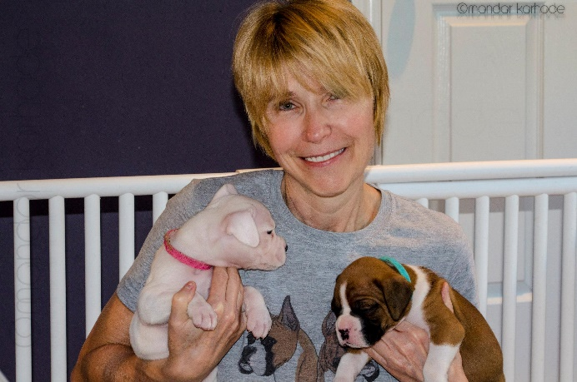
There are no wrong answers! I just need to get to know you, your family and situation as well as possible in order to make the best match possible between you and your new puppy! Please be as truthful & descriptive as possible.

- How did you hear about Gentry Boxers?
- Have you owned any dogs before?
- Please elaborate on any experience you have with boxers.
- What aspect of my breeding program specifically draws you to submit a puppy application?
- List the names, ages and species of all pets in your home.
- If you have other dogs, please tell me about their individual training and personalities.
- List the names and ages of all persons living in your home.
- If you have children, what is their experience with dogs at this point in time?
- What is your housing situation?
- What containment situation for you have in place to keep the puppy safe & secure?
- Will someone be home during the day with your puppy?
- What arrangements can you make for care while you are at work or away?
- Where will your dog sleep?
- What experience do you have with crate training?
- Who will be responsible for taking care of and training the puppy?
- What experience do you have with positive reinforcement/clicker training?
- What experience and education do you have with Natural Rearing practices?
- Are you willing to continue on with Natural Rearing practices with this dog?
- Do you need instruction or coaching in a Natural lifestyle for your Boxer?
- Have you researched Holistic Vets or Naturopaths in your area?
- Is your veterinarian trained in holistic practices? Describe any alternative methods that they offer.
- What experience do you have with feeding a Species Appropriate Raw Diet?
- What experience or education do you have relative to using injectable vaccinations?
- We are working to increase longevity in our Boxers with great health. If your Boxer lives well into its teens, are you prepared to provide a "lifetime" home for your dog?
- What types of activities do you enjoy or want to do with your Gentry boxer?
- Are you willing to do performance or conformation titling? If so which sports are you interested in participating in?
- Do you have a preference on color or gender?
- If interested in a female, would you be willing to partner (co-own) with me and breed her after she is fully health screened to help continue our efforts to bring naturally reared Boxers into the population?
- If interested in a male, are you willing to fully health screen him, co-own with me and allow us access to breed to him if we desire?
- Are you willing to leave your dog intact?
- References: Please provide veterinary reference(s) and any breeders you have worked with in the past. I need full contact information so that I can call/e-mail them.
- Is there anything else you want me to know about you? Please feel free to attach pictures!
- Please provide me with your full name, address, phone #, email website.
- Please send me a friend request on Facebook as I communicate much information using social media. Thanks!

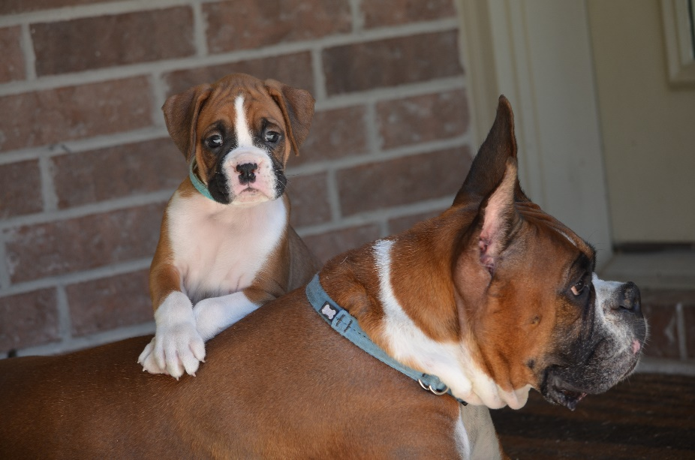

*Our pups are naturally bred & whelped, raised by their mother, weaned to a prey model raw diet & are not vaccinated, chemically treated or chemically wormed (we do use Natural Methods). They will be well socialized, desensitized to many common startling conditions, exposed to Bio Sensor stimulation, and started on training and house training.

*All pups will be checked by my holistic veterinarian and guaranteed not to have any communicable diseases or parasite infestations.

*I will require you to sign a Puppy Contract when you pick up your puppy. I will also provide you with an information folder, comfort toy/object for the pup, and food for the road, if needed.

*Pups must be paid for in full, before they are taken home with you. Please contact me for specific pricing.

* Each pup will be specifically selected for each family, consideration given to meeting the needs of each family and puppy. This will require open communication between myself and prospective puppy parents, as we will work together to pick the best puppy for you, considering preferences, and most importantly, the pup's compatibility with you, your family & situational needs. Every puppy has a distinct attitude/personality and I want to make sure you get the pup best suited to you! I reserve the right to select the puppy and to refuse a puppy to someone if, for any reason, I think it is in the pup's best interests.

*I prefer that puppies are picked up in person, but will consider shipping via PetSafe if circumstances do not allow personal pickup. I realize this may require planning and a long trip for some & I am willing to work with prospective owners on the time frame of their trip. We do live near Houston, and there are lots of fun things to do in Texas!

*For more information on how we raise our wonderful, naturally healthy puppies see our website at www.gentryboxers.com
*I look forward to this endeavor of puppy raising and also to communicating with & meeting the prospective puppy families! If you have any questions, please feel free to call me, email me or message me on Facebook.
Thank you.
Paula Vandervoort
Gentry Boxers

Best ways to communicate with me are email and Facebook.
paula@gentryboxers.com
Facebook: Paula Vandervoort (There is a Gentry Boxers page, but I don’t update it often or monitor it very well)
713-283-7557 (land line)

